WORK INTERGRATED LEARNING
MODULE CODE: XISD5319

TASK 2

TEAM NAME: Core3 Systems

GROUP MEMBERS
RAFIQAH KIRBY - ST10438554
ARMALENE MAGERMAN - ST10454097
CHLOE LANGENHOVEN - ST10435895


NAME OF CLIENT
Iziko Museums of South Africa
(ART GALLERY)
Chief Educator: Art - Rory Emmett

Table of Contents
Introduction 3
Solution Domain 5
Functional Requirements 5
Solution domain table 5
Explanation of the System 6
UML USE CASE DIAGRAM 7
Conclusion 7
Logical System Model 8
Explanation of the Logical System Model 9
Class Diagrams 10
Class Diagram Table 10
Domain Class Diagram 12
References 14
Github 15
GitHub Link : 15
What can be found on GitHub: 15

Introduction

The goal of our project is to design and develop a mobile application for the Iziko Art Gallery in South Africa that will enable users to access and experience artwork digitally. The system is meant to modernize the museum experience by making artwork and educational content more accessible to both local and international audiences through mobile technology. Currently, visitors can only experience the artwork by physically visiting the Iziko Art Gallery. While this offers an authentic museum experience, it creates several limitations for users who live outside of Cape Town or abroad, as tourists, researchers, and younger audiences may not always be able to visit the museum. By using mobile technology to make artwork and instructional information more accessible to both domestic and foreign audiences, the system aims to modernize the museum experience.
Visitors can currently only view the artwork in person at the Iziko Art Gallery. For customers who reside outside of Cape Town or overseas, this presents several constraints even though it offers a realistic museum experience. It might not always be possible for visitors, scholars, students, and younger audiences to visit the museum. As time goes on, a lot of people will opt to using smartphones, tablets, and internet platforms to obtain information digitally.
Mr. Rory from the Iziko Art Gallery recognized the need for a digital solution that can preserve and promote South African cultural heritage while boosting public involvement with art. The current method mostly uses printed materials, guided tours, and in-person visits to provide information about artwork and exhibitions. This restricts accessibility and lowers chances for ongoing interaction after visitors depart the museum. The museum will be virtually expanded by the suggested mobile application. In addition to viewing instructional videos, users will be able to peruse collections of artwork, read biographies of artists and their histories, and scan QR codes inside the museum to access more digital content.
Younger audiences, who are more accustomed to mobile technology and digital learning environments, will find the application's interactive and instructive platform more appealing. By enabling authorized administrators to effectively upload, update, and manage artwork information through a centralized system, the application will also assist museum administration. The digital platform will enhance communication, accessibility, and organization between the museum and its patrons.
The main objectives of the system are:
- To provide digital access to museum artwork and collections.
- To increase engagement with African art among younger audiences.
- To support educational learning through multimedia content.
- To improve accessibility for international visitors and remote users.
- To modernise the museum experience using mobile technology.
- To promote South African cultural heritage globally.

Kotlin and Android Studio will be utilized in the development of the suggested system, with MySQL serving as the database management system. Multimedia content, QR code scanning, search capabilities, artwork browsing, user registration, and administrative management tools are just a few of the features that the application will offer.
The system is deemed practical even though the project will be created with student resources and low finance because the team members already have access to the hardware resources and the necessary software tools are freely available. Planning, frequent communication, and the usage of backup systems like GitHub and cloud storage will all help to mitigate potential risks like time limits, poor internet connectivity, and a lack of development experience.
The Iziko Museum of South Africa will gain from the successful deployment of this mobile application by gaining more international recognition, enhancing educational accessibility, and giving visitors from all over the world a more innovative and engaging museum experience.

Solution Domain

Functional Requirements
The functional requirements explain what the system must do and who will use the system. The proposed system is the Iziko Museum Mobile Application. The app will allow users to explore African art digitally, scan QR codes, watch educational videos, and learn more about artworks. Functional requirements are important because they describe the interaction between the users and the system functions (Kendall and Kendall, 2019).

Solution domain table
Participant (Active Actor) | Function of the System | Participant (Passive Actor)
Visitor / Tourist | View artwork on the mobile app | Iziko Museum Database
Visitor / Tourist | Read information about artworks | Artwork Collection
Visitor / Tourist | Watch educational videos about art | Video System
Visitor / Tourist | Scan QR codes in the museum | QR Code System
Visitor / Tourist | Search for artworks or exhibitions | Database
Admin | Upload new artworks | Mobile App System
Admin | Update artwork descriptions | Database
Admin | Manage videos and gallery content | Mobile App System
Admin | View user activity and tracking reports | Tracking System
Developer | Maintain and update the application | System Server
Firebase/MySQL Database | Store user and artwork information | Mobile App
QR Scanner System | Read QR codes and display artwork details | Visitor / Tourist

Explanation of the System
The Iziko Museum Mobile App helps visitors learn about African art using their mobile phones and tablets. The system allows users to browse artwork digitally, read artwork descriptions, watch educational videos, scan QR codes, and search for exhibitions and artworks. UML use case diagrams are used to show how actors interact with the system and its different functions (Sommerville, 2016).
The main purpose of the system is to make African art more accessible to tourists, students, and young people who may not be able to visit the museum physically. The mobile application will create an easier and more interactive way for users to experience art and culture through technology. System analysis and design help organisations develop systems that meet user needs effectively (Hoffer, George and Valacich, 2016).
The admin user will be responsible for managing the content inside the application. The admin can upload new artworks, update artwork descriptions, manage videos, and monitor user activity reports. The developer will maintain and update the application when necessary to ensure the system works properly and efficiently. Software engineering principles are important to maintain the quality and performance of software applications (Pressman and Maxim, 2019).
The system will also connect with external systems such as the QR Scanner System, Video System, and Firebase/MySQL Database. The database will store artwork information, videos, and user activity records. The use of database systems helps improve data storage and management within mobile applications (Oracle, 2026). Firebase can also be used for cloud storage and real-time database services within the application (Google, 2026).
The application is being developed for the Iziko Museums of South Africa to improve digital access to African art collections and increase interaction with tourists and younger audiences (Iziko Museums of South Africa, 2026).

UML USE CASE DIAGRAM
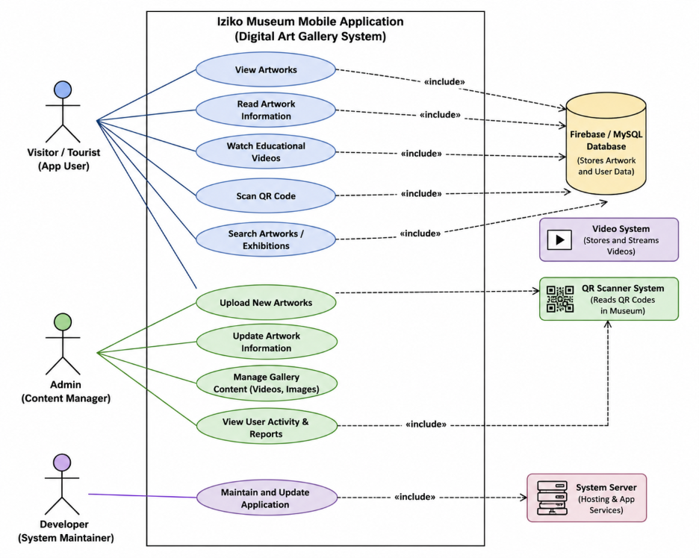

Conclusion
The Iziko Museum Mobile Application will help improve access to African art through a digital platform. The UML Use Case Diagram shows how different actors interact with the system and its functions. The application will support learning, cultural awareness, and user interaction through modern mobile technology. Proper project planning and system development processes are important for the successful completion of software projects (Schwalbe, 2019).

Logical System Model

GUI |  | System Process (Method) | Entity Relationship (Table)
Input | Output
Enter user details | Registration confirmation | Register a new user | User Table
Username and password | User dashboard | Authenticate user login | User Table
Select menu option | Navigation to selected feature | Load application dashboard | User Table
Search/filter artwork | Artwork list displayed | Display artwork gallery | Artwork Table
Select artwork | Artwork information and images | Retrieve artwork details | Artwork Table
Enter artwork keyword | Matching artwork results | Search artwork records | Artwork Table
Scan QR code | Artwork information displayed | Retrieve artwork using QR code | QR Code Table
Select educational video | Video playback | Display educational content | Video Table
Select “Save Favourite” | Favourite saved message | Save favourite artwork | Favourite Table
Update user details | Updated profile confirmation | Update user information | User Table
Enter artwork details | Artwork successfully added | Add new artwork | Artwork Table
Update artwork information | Updated artwork details | Edit artwork information | Artwork Table
Select artwork to remove | Artwork deleted confirmation | Delete artwork | Artwork Table
Upload video details | Video uploaded successfully | Upload educational video | Video Table
Request report generation | User activity report | Generate usage report | UserActivity Table
Select logout option | Return to login screen | End user session | User Table

Explanation of the Logical System Model

The logical system model describes how data would be processed between the database entities, system operations, and user interface of the intended Iziko Museum mobile application. This model is essential because it illustrates how the system reacts to inputs and outputs as well as how people interact with it. A logical system model, according to Kendall and Kendall (2019), aids developers in understanding the system's linkages, data flow, and operations prior to implementation.
African artwork, educational materials, and user engagement via a mobile application are all supported by the system's design. The graphical user interface (GUI), database tables, necessary inputs, system outputs, and system procedures are all identified in the model below.
The mobile application's data processing between the user and the database system is illustrated by the logical system model. All registered user information, login credentials, and profile information are kept in the User Table. Details on the artworks, creators, categories, and descriptions that are shown in the digital gallery are stored in the Artwork Table.
Users can obtain more information digitally by scanning QR codes posted next to artwork in the museum using the QR Code Table. Educational videos about African art and museum exhibits are kept in the Video Table. While the UserActivity Table keeps activity logs for reporting and monitoring user interaction, the Favourite Table keeps track of artwork that users have bookmarked for later viewing.
As administrators maintain and oversee digital museum material, the system operations listed in the table enable that users can engage with the application efficiently. Logical system models, according to Hoffer, George, and Valacich (2016), enhance system planning because they offer a clear depiction of procedures, inputs, outputs, and database interactions prior to the start of construction.

Class Diagrams

Class Diagram Table
The class diagram table is used to list all the main classes in the Iziko Museum Mobile Application. Each class represents a part of the system, such as a User, Artwork, or QR Code. The table shows the name of each class, the information it stores, and which other classes it is connected to. This helps the team plan the system before building it. Class diagrams help developers understand what data the system needs and how different parts of the system work together (Sommerville, 2016).
The classes in this system were identified by looking at the logical system model and finding all the entities listed there. Each class was given properties with data types, such as string or integer, and character limits to show how much data can be stored. The relationships between classes, such as User being connected to Review, show how the classes share and use data in the system. According to Pressman and Maxim (2019), identifying classes and their properties early in the design process helps make sure the system is well planned before coding begins.

Name of entity (UML Class) | Properties of entity (UML Class) | Related to:
User | userID (int), username (string — 30 characters), email (string — 50 characters), password (string — 20 characters), userType (string — 10 characters) | Review, Visit
Artwork | artworkID (int), title (string — 50 characters), artist (string — 40 characters), year (int), description (string — 200 characters), imageURL (string — 100 characters) | Gallery, Category, Review, QR Code
Gallery | galleryID (int), galleryName (string — 50 characters), location (string — 50 characters), floor (string — 10 characters) | Artwork
Category | categoryID (int), categoryName (string — 30 characters), description (string — 100 characters) | Artwork
Review | reviewID (int), rating (int), comment (string — 200 characters), datePosted (date) | User, Artwork
Admin | adminID (int), adminName (string — 30 characters), email (string — 50 characters), password (string — 20 characters) | Artwork, Gallery
Visit | visitID (int), visitDate (date), duration (int), deviceType (string — 20 characters) | User
QRCode | qrCodeID (int), qrData (string — 100 characters), generatedDate (date) | Artwork

Domain Class Diagram

The domain class diagram is a visual drawing that shows all the classes in the system and how they are connected to each other. Each class box has three parts: the class name at the top, its attributes in the middle, and its operations at the bottom. The diagram was drawn using Draw.io and is based on the eight classes identified in the class diagram table, which are User, Artwork, Gallery, Category, Review, Admin, Visit, and QR Code. The diagram makes it easy to see how the whole system is structured (Hoffer, George and Valacich, 2016).
The lines between the classes show the relationships between them. An association line means two classes are connected and share information with each other. For example, a User is connected to Review because a user can write a review. Artwork is connected to Gallery, Category, QR Code, and Review because artwork is the main part of the system that links to everything else. Admin is connected to Artwork and Gallery because the admin manages that content. These relationships show how the different parts of the system work together to make the app function correctly (Kendall and Kendall, 2019).

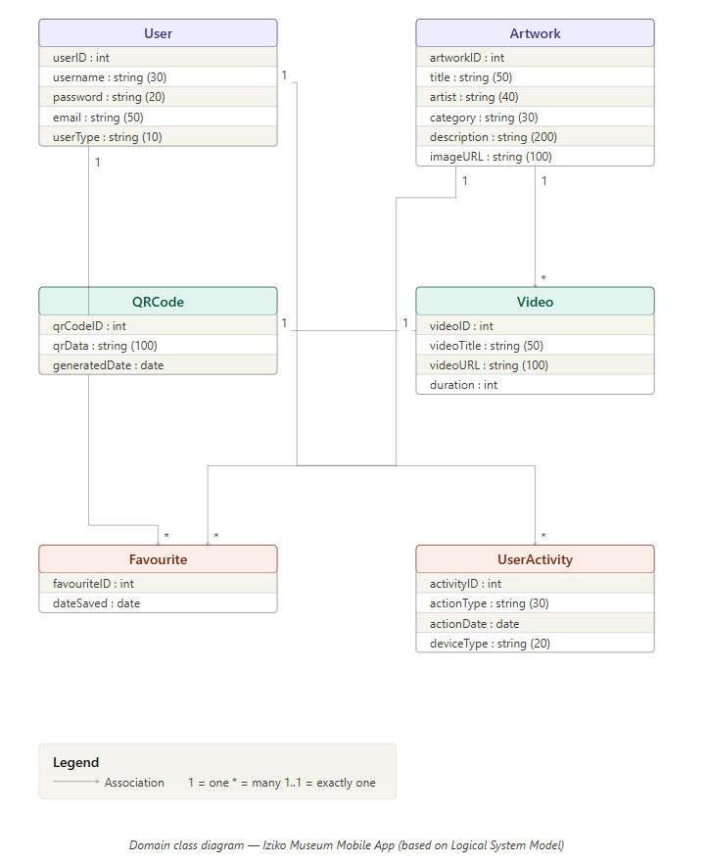

References

Hoffer, J.A., George, J.F. and Valacich, J.S. (2016) Modern Systems Analysis and Design. 9th edn. Harlow: Pearson.
Iziko Museums of South Africa (2026) Official website. Available at: https://www.iziko.org.za (Accessed: 12 May 2026).
Kendall, K.E. and Kendall, J.E. (2019) Systems Analysis and Design. 10th edn. Harlow: Pearson.
Oracle MySQL Documentation (2026) MySQL Documentation. Available at: https://dev.mysql.com/doc/ (Accessed: 12 May 2026).
Pressman, R.S. and Maxim, B.R. (2019) Software Engineering: A Practitioner’s Approach. 9th edn. New York: McGraw-Hill Education.
Schwalbe, K. (2019) Information Technology Project Management. 9th edn. Boston: Cengage Learning.
Sommerville, I. (2016) Software Engineering. 10th edn. Boston: Pearson.

Github

GitHub Link :

ST10438554-kirby/XISD5311_IZIKO_ARTGALLERY

What can be found on GitHub:
- XISD5311_Task 1
- Analysis Document
- System Design Document

